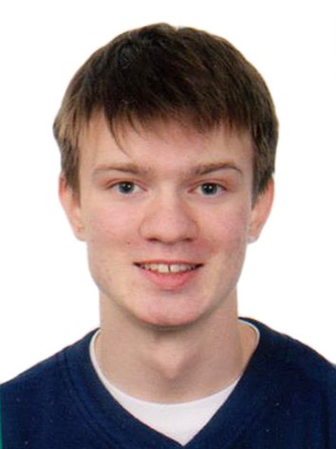Oleg Pedorenko

|  |  |  |
| --- | --- | --- |
| e-mail:  phone:  skype: | [oleg.pedorenko@gmail.com](mailto:oleg.pedorenko@gmail.com)  +38 (067) 645-92-98  +38 (063) 481-7-184  oleh.pedorenko | vul. Ak. Yangelya 22, 4-12  Kiev, Ukraine  03056 |
| linkedin: | linkedin.com/in/auliere |  |

# Education summary

*National Technical University of Ukraine “Kyiv Polytechnic Institute”* 2017 – Present

Kyiv, Ukraine

Master’s Degree in Software Engineering

*National Technical University of Ukraine “Kyiv Polytechnic Institute”* 2013 - 2017

Kiyv, Ukraine

Bachelor’s Degree in Software Engineering

**Course highlights:** C/C++ Programming, Basics of Software Engineering, Object Oriented Programming, Algorithms and Data Structures, Discrete Mathematics and Data Structures, Web Design, .NET Programming, Database Programming, Functional Programming,   
Parallel Programming.

*Palace of Children and Youth*  2007 - 2013

Vinnytsia, Ukraine

Courses of Programming

**Course highlights:** Programming in Pascal, Programming in Delphi, Programming in C#, Algorithms and Olympiad Programming.

*Holland High School* 2011-2012

Holland, MI, USA

High school studies as a part of an exchange program

**Summary:** studied various subjects including Java Programming, Speech and Pre-Calculus.

*Secondary Education School #29* 2002-2013

Vinnytsia, Ukraine

School

# Work experience

*EPAM Systems* 2016 – Present

**Title:** Junior Software Engineer/Software Engineer

**Description**: Developed integration interfaces for one of the leading mortgage automation solution providers on the US market.

**Technologies:** C#, .NET, XML, XSLT, SpecFlow, WCF, WebAPI, Knockout.JS, MS SQL, Altova MapForce, XML Spy, Powershell

*EPAM Systems* 2015 – 2016

**Title:** Student/Trainee in Business Intelligence

**Responsibilities**: Study BI practices, develop pet projects

**Technologies:** Oracle 11g, Informatica, MySQL

*Student social service of NTUU KPI* 2015 – Present

**Title:** Volunteer

**Responsibilities**: develop and deploy a system to keep and manage data about blood donors for the Student social service.

**Technologies:** Oracle 11g, C#, .NET, WPF

# Technologies

Technologies and programming languages listed here are ordered by my experience with them, most experience first.

*Programming languages:*

C#/.NET, C/C++, Java, Pascal/Delphi, Python, Lisp, Ada

*IDE and editors:*

MS Visual Studio, Eclipse, Borland Pascal, Borland Delphi, Embarcadero RAD Studio, Dev-C++, Qt Creator, BlueJ, Unity, Atom, MySQL Workbench

*Database Management System:*

Microsoft SQL Server, Oracle 11g, MySQL

*Team development/Version Control System:*

Team Foundation Server/Visual Studio Team Services, Github/Git

*Continuous integration and Continuous deployment:*

Octopus Deploy, Team Foundation Server

# Other information

*Languages:*

Native: Russian, Ukrainian;

Upper Intermediate: English.

I have participated in the FLEX (Future Leaders Exchange) Program, funded by the Department of State of the United States of America. I have lived in an American host family in Holland, Michigan, for a year, while studying at school and committing over 40 hours of volunteering for local community.

An online copy of this CV is availaible at

<https://github.com/auliere/CurriculumVitae/raw/master/Oleg%20Pedorenko_CV.pdf>

A single-page, printer-friendly version of this CV is availaible at:

<https://github.com/auliere/CurriculumVitae/raw/master/Oleg%20Pedorenko_CV_printer.pdf>